Authoritative Server
# Source: AI Source: Provided by: [Data Path: Persons Table -> ID Column: 1, Name_En Column: Motasem Essam] -> From: [ChatGPT] on [1/18/2026]
An Authoritative DNS Server is the final source of truth in the DNS lookup process.
It holds and serves the actual DNS records (like A, MX, CNAME) for a specific domain name (e.g., example.com).
✅ It’s the server that gives the official answer:
“The IP address for example.com is 93.184.216.34.”

🔁 DNS Lookup Journey Recap
# Source: AI Source: Provided by: [Data Path: Persons Table -> ID Column: 1, Name_En Column: Motasem Essam] -> From: [ChatGPT] on [1/18/2026]
- You type www.example.com in your browser.
- Your DNS resolver goes to:
  - Root Server → gives location of .com TLD
  - TLD Server → gives location of example.com's Authoritative Server
- Finally, it contacts the Authoritative DNS Server, which responds with:
  - ✅ IP address of the domain
  - Or ❌ "No such domain" (NXDOMAIN)

🗂️ What Does It Store?
# Source: AI Source: Provided by: [Data Path: Persons Table -> ID Column: 1, Name_En Column: Motasem Essam] -> From: [ChatGPT] on [1/18/2026]
An Authoritative DNS Server contains DNS zone files with records such as:
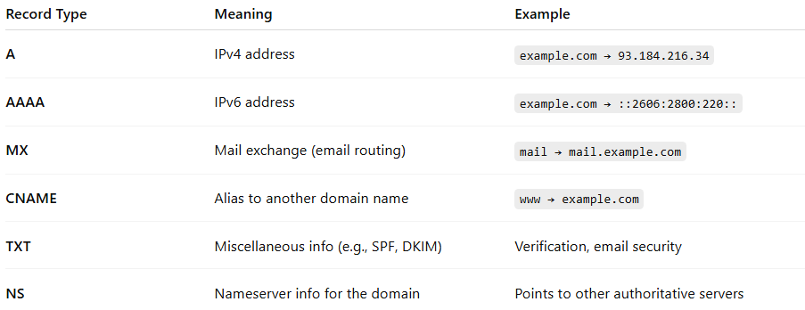

Record Type | Meaning | Example
A | IPv4 address | example.com → 93.184.216.34
AAAA | IPv6 address | example.com → ::2606:2800:220::
MX | Mail exchange (email routing) | mail → mail.example.com
CNAME | Alias to another domain name | www → example.com
TXT | Miscellaneous info (e.g., SPF, DKIM) | Verification, email security
NS | Nameserver info for the domain | Points to other authoritative servers

🔍 Two Types of Authoritative Servers
# Source: AI Source: Provided by: [Data Path: Persons Table -> ID Column: 1, Name_En Column: Motasem Essam] -> From: [ChatGPT] on [1/18/2026]


Type | Description
Primary | Stores the original zone file
Secondary | Keeps a read-only copy, synced from primary

1-Authoritative Server Primary

✅ What is an Authoritative DNS Server (Primary)?
# Source: AI Source: Provided by: [Data Path: Persons Table -> ID Column: 1, Name_En Column: Motasem Essam] -> From: [ChatGPT] on [1/18/2026]
An Authoritative DNS Server (Primary) is a type of DNS server that holds the original source records (zone file) for a domain — meaning it is the ultimate authority for answering DNS queries for that domain.
It’s like the official record keeper for a domain name.

📘 Simple Definition:
# Source: AI Source: Provided by: [Data Path: Persons Table -> ID Column: 1, Name_En Column: Motasem Essam] -> From: [ChatGPT] on [1/18/2026]
The Primary Authoritative DNS Server is where the DNS zone (the database of records like A, MX, CNAME, etc.) is created and managed.

📦 Example:
# Source: AI Source: Provided by: [Data Path: Persons Table -> ID Column: 1, Name_En Column: Motasem Essam] -> From: [ChatGPT] on [1/18/2026]
If your domain is example.com, the primary authoritative server knows:
- What IP address example.com points to
- Where email for example.com should go (MX records)
- What subdomains exist (www.example.com, etc.)

🧠 Key Concepts:
# Source: AI Source: Provided by: [Data Path: Persons Table -> ID Column: 1, Name_En Column: Motasem Essam] -> From: [ChatGPT] on [1/18/2026]
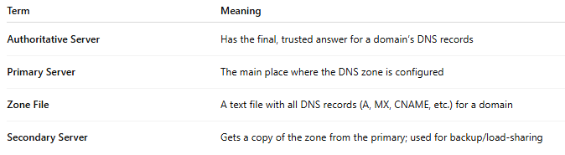
Term | Meaning
Authoritative Server | Has the final, trusted answer for a domain’s DNS records
Primary Server | The main place where the DNS zone is configured
Zone File | A text file with all DNS records (A, MX, CNAME, etc.) for a domain
Secondary Server | Gets a copy of the zone from the primary; used for backup/load-sharing

🔄 Primary vs Secondary DNS Server
# Source: AI Source: Provided by: [Data Path: Persons Table -> ID Column: 1, Name_En Column: Motasem Essam] -> From: [ChatGPT] on [1/18/2026]
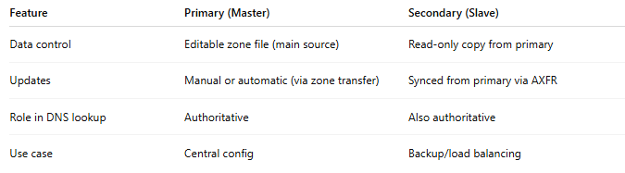
Feature | Primary (Master) | Secondary (Slave)
Data control | Editable zone file (main source) | Read-only copy from primary
Updates | Manual or automatic (via zone transfer) | Synced from primary via AXFR
Role in DNS lookup | Authoritative | Also authoritative
Use case | Central config | Backup/load balancing

✅ Summary
# Source: AI Source: Provided by: [Data Path: Persons Table -> ID Column: 1, Name_En Column: Motasem Essam] -> From: [ChatGPT] on [1/18/2026]
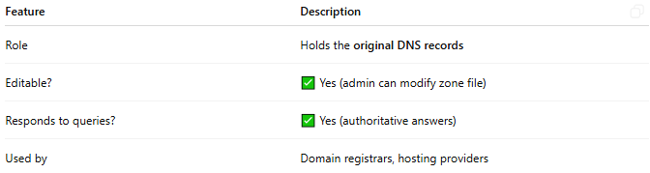
Feature | Description
Role | Holds the original DNS records
Editable? | ✅ Yes (admin can modify zone file)
Responds to queries? | ✅ Yes (authoritative answers)
Used by | Domain registrars, hosting providers

Would you like to see an example of a zone file on a primary DNS server or how to set one up?

2-Authoritative Server Secondary

✅ What is an Authoritative DNS Server (Secondary)?
# Source: AI Source: Provided by: [Data Path: Persons Table -> ID Column: 1, Name_En Column: Motasem Essam] -> From: [ChatGPT] on [1/18/2026]
An Authoritative Secondary DNS Server is a backup server that stores a read-only copy of the DNS zone from the Primary (Master) server.
It helps with redundancy, load balancing, and fault tolerance, but it cannot be edited directly.

📘 Simple Definition:
# Source: AI Source: Provided by: [Data Path: Persons Table -> ID Column: 1, Name_En Column: Motasem Essam] -> From: [ChatGPT] on [1/18/2026]
A Secondary DNS Server is authoritative for a domain but does not contain the original zone file. Instead, it gets the DNS records from the Primary server using a process called a zone transfer.

🧠 Key Concepts
# Source: AI Source: Provided by: [Data Path: Persons Table -> ID Column: 1, Name_En Column: Motasem Essam] -> From: [ChatGPT] on [1/18/2026]
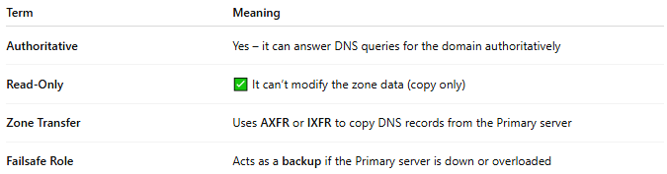
Term | Meaning
Authoritative | Yes – it can answer DNS queries for the domain authoritatively
Read-Only | ✅ It can’t modify the zone data (copy only)
Zone Transfer | Uses AXFR or IXFR to copy DNS records from the Primary server
Failsafe Role | Acts as a backup if the Primary server is down or overloaded

🔄 Primary vs Secondary DNS Server
# Source: AI Source: Provided by: [Data Path: Persons Table -> ID Column: 1, Name_En Column: Motasem Essam] -> From: [ChatGPT] on [1/18/2026]
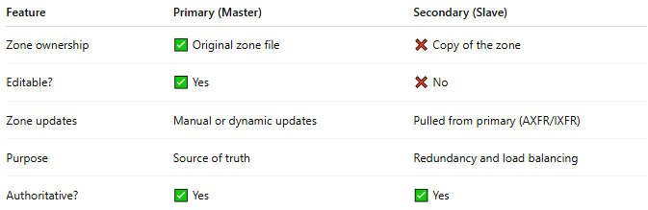
Feature | Primary (Master) | Secondary (Slave)
Zone ownership | ✅ Original zone file | ❌ Copy of the zone
Editable? | ✅ Yes | ❌ No
Zone updates | Manual or dynamic updates | Pulled from primary (AXFR/IXFR)
Purpose | Source of truth | Redundancy and load balancing
Authoritative? | ✅ Yes | ✅ Yes

🔁 Example Use Case
# Source: AI Source: Provided by: [Data Path: Persons Table -> ID Column: 1, Name_En Column: Motasem Essam] -> From: [ChatGPT] on [1/18/2026]
Suppose you own example.com:
- Primary DNS: ns1.example.com (zone created here)
- Secondary DNS: ns2.example.com (pulls zone from primary)
If ns1 is down, ns2 can still answer DNS queries.

✅ Summary
# Source: AI Source: Provided by: [Data Path: Persons Table -> ID Column: 1, Name_En Column: Motasem Essam] -> From: [ChatGPT] on [1/18/2026]
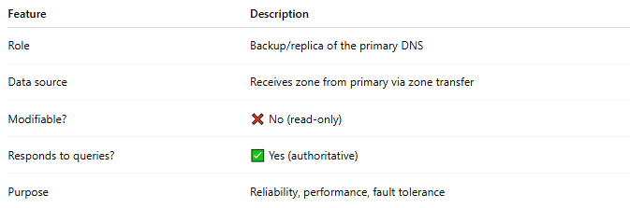

Feature | Description
Role | Backup/replica of the primary DNS
Data source | Receives zone from primary via zone transfer
Modifiable? | ❌ No (read-only)
Responds to queries? | ✅ Yes (authoritative)
Purpose | Reliability, performance, fault tolerance

📍 Example in Action
# Source: AI Source: Provided by: [Data Path: Persons Table -> ID Column: 1, Name_En Column: Motasem Essam] -> From: [ChatGPT] on [1/18/2026]
You want to go to:
🔗 www.example.com
The Authoritative Server responds:
➡️ “That domain maps to 93.184.216.34.”

🔐 Important Notes
# Source: AI Source: Provided by: [Data Path: Persons Table -> ID Column: 1, Name_En Column: Motasem Essam] -> From: [ChatGPT] on [1/18/2026]
- It does NOT cache answers like recursive resolvers do.
- If it doesn't have the record, it returns an error (e.g., NXDOMAIN).
- It's responsible for the accuracy and control of the domain's DNS settings.

✅ Summary
# Source: AI Source: Provided by: [Data Path: Persons Table -> ID Column: 1, Name_En Column: Motasem Essam] -> From: [ChatGPT] on [1/18/2026]
Authoritative Server = Final answer for a domain's DNS info
🏁 Stores official DNS records
📡 Responds directly to DNS resolvers
🛠️ Managed by domain owners, hosting providers, or registrars
🧱 Foundation of domain name control and internet identity

